Developer guide

jWebSocket
GlassFish (Grizzly) Engine
1.0

Versions control
Date | Version | Description | Author
15/05/2012 | 1.0 | Document creation | Victor Antonio Barzana Crespo

- Overview
This guide describes how to modify, configure and use GlassFish (Grizzly) engine for jWebSocket, shows how to develop, assemble and deploy applications using this engine.
Nowadays Web Servers, Servlet Containers and Application Servers from Java Platform such as Tomcat, Jetty, JBoss Netty, Grizzly, WebSphere, Oracle AS, GlassFish and others already offer support to the WebSocket protocol. A Servlet Container in J2EE Architecture is used to manage the components like servlets, JSP. It provides a runtime environment to the components of J2EE. Whenever a web server receive a request it forward it to the web container which deals with it by instantiating, initializing and invoking Servlets and JSP pages. Basically a Web Server is capable of handling HTTP request send by a client and respond back with a HTTP respond. In other side, an Application Servers, also known as App Servers, consists in a server which provides software applications with services such as security, data services, transaction support, load balancing, and management of large distributed systems.
One of the most important open source Application Servers of the Java platform is GlassFish; it is a production-ready, Java EE-compatible application server and provides a fully-featured implementation of Java EE 6. It uses a derivative of Apache Tomcat as the servlet container for serving Web content, with an added component called Grizzly which uses Java New I/O (NIO) for scalability and speed. Grizzly framework has a rapidly process for developing applications that require client-server communication at low level.
jWebSocket framework, in order to benefit from these servers, integrates and reuses them, mainly getting from them the protocol and connection management implementation, message transmission and consumption of memory, these integrations are called jWebSocket Engines. Grizzly can easily be integrated in jWebSocket or jWebSocket in GlassFish Apps. The Grizzly Integration and GlassFish Wrapper is a jWebSocket extension that allows thousands of clients to establish a low-level communication with the GlassFish application server and resume sending and receiving packets transparently to users.
- Infrastructure, Model, Approach
Grizzly library can be extended in different places, from a low level byte stream administration to an advanced thread management. The fact that jWebSocket is using the Grizzly framework as a driver for integration with GlassFish, provides to jWebSocket users a product with high performance and scalability in environments where multiple concurrent connected clients be needed.
The structure of the solution is composed of four main parts:

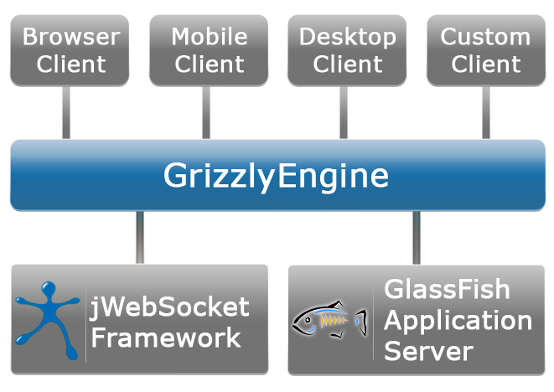
The client side: Any Mobile, Browser, Desktop Software or any other client that implements the last draft of WebSocket protocol to establish a connection with the server.
GlassFish Application Server: The application server itself, jWebSocket framework will be integrated into it.
GrizzlyEngine: The engine to reuse all the WebSocket implementation of Grizzly and include it in jWebSocket Framework.
jWebSocket Framework: Extensible, highly configurable and robust Java and JavaScript Open Source Framework, created to develop WebSocket Applications.
Reusing Grizzly WebSocket implementation, jWebSocket Framework reaches a new engine, a big community and a very powerful tool which can be used to create WebSocket applications approaching all advantages of both, Grizzly and jWebSocket. This engine is aimed to approach ports 80 and 443 using Grizzly-WebSockets.
Grizzly Community
Grizzly is heavily used, accepted and supported by the community, currently there are many companies and projects using this NIO based implementation:
- Tango (WSIT) JRuby on Rails
- Alaska (Open ESJ)
- GlassFish
- Phobos (NetBeans Integration)
- AsyncWeb: (built on top of the excellent Mina network framework) employs non-blocking selector driven IO at the transport level, and is asynchronous throughout - from the initial parsing of requests, right through to and including the services implemented by users.
- Requirements.
GrizzlyEngine is compiled in a separate jWebSocketGrizzlyEngine.jar, this module contains the basic structure of the engine, the project configuration file is pom.xml, which is an XML representation of Maven Project that allows configuring the basic dependencies and properties of the project. This file contains several Maven Plug-ins. To allow exporting all sources of the Project inside a jWebSocketGrizzlyEngine.jar file, we should firstly see the configuration of maven-jar-plugin:
<plugin>
<artifactId>maven-jar-plugin</artifactId>
<groupId>org.apache.maven.plugins</groupId>
<version>2.3.1</version>
<executions>
<!-- create embedded version unpackaged -->
<execution>
<id>Standard</id>
<goals>
<goal>jar</goal>
</goals>
<configuration>
<finalName>jWebSocketGrizzlyEngine-${project.version}</finalName>
<outputDirectory>../../../rte/jWebSocket-${project.version}/libs </outputDirectory>
<archive>
<manifest>
<addClasspath>true</addClasspath>
<mainClass>org.jwebsocket.console.JWebSocketServer</mainClass>
</manifest>
</archive>
</configuration>
</execution>
</executions>
</plugin>
Once the Project is compiled, its sources are stored in the folder: $JWEBSOCKET_HOME/rte/jWebSocket-1.0/libs/ and there will be copied jWebSocketGrizzlyEngine.jar.
Grizzly dependencies can be configured in the dependencies section: <dependencies></dependencies> of the same file pom.xml:
<dependencies>
<!-- Grizzly Http Server -->
<dependency>
<groupId>org.glassfish.grizzly</groupId>
<artifactId>grizzly-http-server</artifactId>
<version>2.2.5</version>
</dependency>

<!-- Grizzly WebSockets Server -->
<dependency>
<groupId>org.glassfish.grizzly</groupId>
<artifactId>grizzly-websockets-server</artifactId>
<version>2.2.5</version>
</dependency>
<!-- Grizzly WebSockets -->
<dependency>
<groupId>org.glassfish.grizzly</groupId>
<artifactId>grizzly-websockets</artifactId>
<version>2.2.5</version>
</dependency>
<dependencies>
The following configuration should be included in your $JWEBSOCKET_HOME/conf/jWebSocket.xml configuration file. jWebSocket Server will select the first engine defined in the <engines> tag from the configuration, the following example shows GrizzlyEngine configuration:
<engines>
<!-- Grizzly Http Server -->
<dependency>
<groupId>org.glassfish.grizzly</groupId>
<artifactId>grizzly-http-server</artifactId>
<version>2.2.5</version>
</dependency>
<!-- Grizzly Engine Configuration -->
<engine>
<name>org.jwebsocket.grizzly.GrizzlyEngine</name>
<id>grizzly0</id>
<jar>jWebSocketGrizzlyEngine-1.0.jar</jar>
<!-- Attention! The jWebSocket Grizzly Engine listens on same port like
Grizzly's http. The http protocol is upgraded to use WebSockets.
The http/websocket port can be configured via the Grizzly
configuration file.
-->
<!-- use 80/443 for default http/ws or https/wss connections
when running a jWebSocket Server and use Grizzly as an engine.
These settings are recommended only when running jWebSocket
on a separate server beside a WebServer and the firewall
does not allow access to ports 8787 and 9797.
-->
<!--
<port>80</port>
<sslport>443</sslport>
-->
<!-- use 8787/9797 for default http/ws or https/wss connections
These settings are recommended only when running jWebSocket
on the same server beside a WebServer and the firewall
grants access to ports 8787 and 9797.
-->
<port>8787</port>
<sslport>9797</sslport>
<!-- these domains are accepted by the engine listening on the above mentioned port -->
<domains>
<domain>*</domain>
</domains>
<!-- default session timeout 1h, max timeout currently 1 hour -->
<timeout>0</timeout>
<!-- Grizzly engine provides a WebSocket Context to have its applications
under the same context-->
<context>/jWebSocket</context>
<!-- Grizzly needs a WebSocket application path, each application
under the same context can have different paths-->
<servlet>/jWebSocket</servlet>
<!-- maximum size of the data packet that the engine will read,
if the frame size is larger than this the connection will be closed. -->
<maxframesize>1048840</maxframesize>
<!-- maximun number of connections allowed by this engine -->
<maxconnections>10000</maxconnections>
</engine>
<engines>
- Modules, Structure
The Image # shows a component model diagram of the jWebSocket Grizzly Engine.
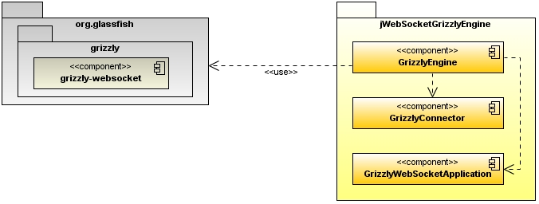
Image # : Component model diagram of jWebSocket Grizzly Engine.

The module jWebSocketGrizzlyEngine contains the basic structure of Grizzly engine, is included in the domain org.jwebsocket.grizzly. The Netbeans package structure of the solution is shown in the following image:
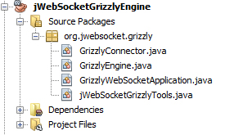
Image # : Package structure for jWebSocket Grizzly Engine.

Package Description:
The module contains the basic files that are needed to run jWebSocket under a Grizzly-http-websocket environment:
- GrizzlyConnector: Is a jWebSocket abstraction of the low level connection to represent each connection between the client and the server.
- GrizzlyEngine: Is the main implementation of the Engine itself, which controls jWebSocket Server behind a Grizzly HTTP and WebSocket Server.
- GrizzlyWebSocketApplication: Is the default Grizzly listener to control WebSocket flow between clients and the server, this application is wrapped by jWebSocket GrizzlyEngine. On each WebSocket message, open/close connection requests, etc. a method is fired inside jWebSocket Server.
- jWebSocketGrizzlyTools: This file contains auxiliary methods to be used by GrizzlyEngine, for example, a method to parse URL parameters.
- Source Code
One of the most important classes is GrizzlyConnector, this class represents an abstraction for jWebSocketServer of the Grizzly connection with each client.
Table # : GrizzlyConnector detailed API description.
Type | Method | Description
java.lang.String | generateUID() | Returns an unic identifier for the user, “host@ port”.
java.net.InetAddress | getRemoteHost() | Returns the host of the connected client.
int | getRemotePort() | Returns the port of the connected client.
java.lang.String | getUsername() | If the user is authenticated with jWebSocket Server, automatically it´s username will be stored in the connector.
void | processPacket(org.jwebsocket.api.WebSocketPacket aDataPacket) | Processes all incoming packages and send them back to jWebSocket.
void | sendPacket(org.jwebsocket.api.WebSocketPacket aDataPacket) | Sends a data package through Grizzly WebSocket.
org.jwebsocket.async.IOFuture | sendPacketAsync(org.jwebsocket.api.WebSocketPacket aDataPacket) | Sends an Asynchronous packet through Grizzly.
void | startConnector() | Starts the connector, notifies in the engine the rest of the connectors and applications of the start of a new connector.
void | stopConnector(org.jwebsocket.kit.CloseReason aCloseReason) | Thrown when a client closes the connection or it is closed by some reason.
java.lang.String | toString() | Prints a message with the user ID, IP and port.

GrizzlyEngine is the most important class of the implementation, contains two WebSocket listeners, a secure and a non secure one. With this engine jWebSocket controls all Grizzly clients. When the engine starts it registers a GrizzlyWebSocketListener which will be responsible for listening all WebSocket requests. The Image # shows a domain diagram with the basic structure of jWebSocket Grizzly Engine. jWebSocketServer is composed by multiple engines, GrizzlyEngine inherits all the main functionalities from jWebSocketBaseEngine. When jWebSocketServer starts, loads the engines defined in the jWebSocket.xml configuration file, registers a WebSocketAddon which has the functionality of notifying all WebSocketApplications of all incoming connections, messages and other important grizzly events. GrizzlyWebSocketApplication is responsible for wrapping these incoming events from the client and fire corresponding events in jWebSocketServer. Whenever a new connector asks for a connection, GrizzlyWebSocketApplication registers a new GrizzlyConnector for the client to keep the connection alive, and then notifies the engine. GrizzlyConnector is the high level abstraction for jWebSocket of the low level communication between the server and the client.
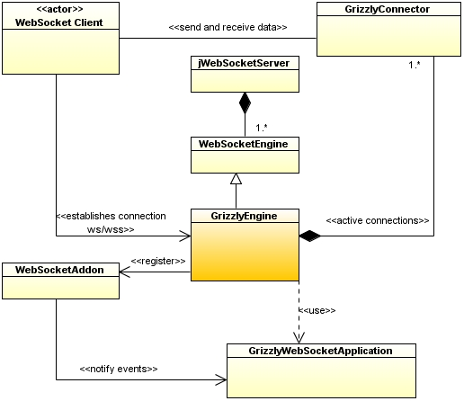
Image # : Domain diagram for jWebSocket Grizzly Engine.

Below is a detailed description of the GrizzlyEngine API with its main functionalities:
Table # : Grizzly Engine detailed API description.
Type | Method | Description
void | connectorStarted(org.jwebsocket.api.WebSocketConnector aConnector) | Notify servers that a connector has started.
void | connectorStopped(org.jwebsocket.api.WebSocketConnector aConnector, org.jwebsocket.kit.CloseReason aCloseReason) | Notify servers that a connector has stopped.
boolean | isAlive() | Is used to know if Grizzly engine is running.
void | startEngine() | Starts GrizzlyEngine, this is the main method of the engine, start the instances of HTTP and WebSocket servers. It is called by the framework, not required to be called manually.
void | stopEngine(org.jwebsocket.kit.CloseReason aCloseReason) | Stops jWebSocket server and sends a message to the connected clients. This method is called by the framework, not required to be called manually.

GrizzlyWebSocketApplication is the default listener application that Grizzly Engine uses to receive many incoming messges. Here I like to see more information about the general approach in Grizzly to deal withWebSocket communication.

Table # : GrizzlyWebSocketApplication detailed API description.
Type | Method | Description
boolean | isApplicationRequest(org.glassfish.grizzly.http.HttpRequestPacket aRequest) | Accepts only requests coming to the engine, otherwise, it will reject the petition to the client.
void | onClose(org.glassfish.grizzly.websockets.WebSocket aSocket, org.glassfish.grizzly.websockets.DataFrame aFrame) | Fired when the connection closes.
void | onConnect(org.glassfish.grizzly.websockets.WebSocket aSocket) | Fired when Grizzly open the connection with a client.
void | onFragment(org.glassfish.grizzly.websockets.WebSocket aSocket, byte[] aFragment, boolean aLast) | Fired when a byte fragment of a package is received.
void | onFragment(org.glassfish.grizzly.websockets.WebSocket aSocket, java.lang.String aFragment, boolean aLast) | Fired when a String fragment of a package is received.
void | onMessage(org.glassfish.grizzly.websockets.WebSocket aSocket, byte[] aBytes) | Fired in the server when a message is received (Bytes).
void | onMessage(org.glassfish.grizzly.websockets.WebSocket aWebsocket, java.lang.String aData) | Fired in the server when a message is received (String).
void | onPing(org.glassfish.grizzly.websockets.WebSocket aSocket, byte[] aBytes) | To know is the server is alive.  ?? One sentence about he ping/pong keep alive mechanism?
void | onPong(org.glassfish.grizzly.websockets.WebSocket aSocket, byte[] aBytes) | ???

